30.10: a) Note that points and are reversed from that of figure 30.6. Thus, according to Equation 30.8, 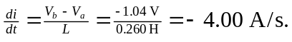 Thus, the current is decreasing.
b) From above we have that 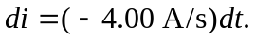 After integrating both sides of this expression with respect to we obtain

